Table of Contents
Collecting Data: 1
Data Terminology: 2
Machine Learning Terminology: 3
AWS Datastores: 4
AWS Migration Tools 5
Streaming Data Collection Concepts 11
Basic Concepts 11
Kinesis Data Streams 13
Kinesis Firehose 17
Kinesis Video Analytics 19
Kinesis Data Analytics 20
Use this API to gather streaming data from the web. 22
Listen before Exam 23
Kinesis 23
Data Preparation 24

Collecting Data:

Goal:

Map out data into AWS

- Arthur Samuel – Some Studies in ML using the Game of Checkers -Whther a computer can be programmed – 1959 – Successful program IBM Journal
- In 1970’s he did it.
- If we can solve a problem using some heuristic model or if else.
- How will it be consumed? Batch or inference.
- Generaly more data means better model training, hence large datasets means good data.
- Mus have atleast 10 times as many data points as the total number of features.
- Data must be congregate into a single data repository.

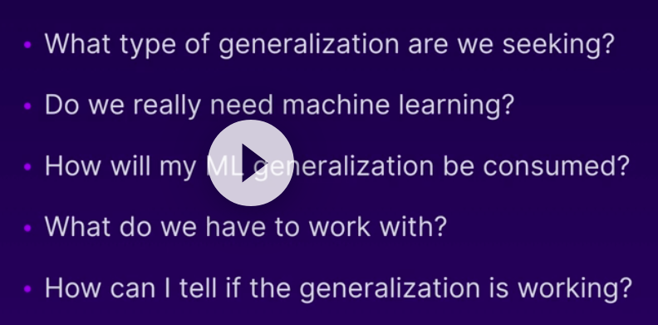

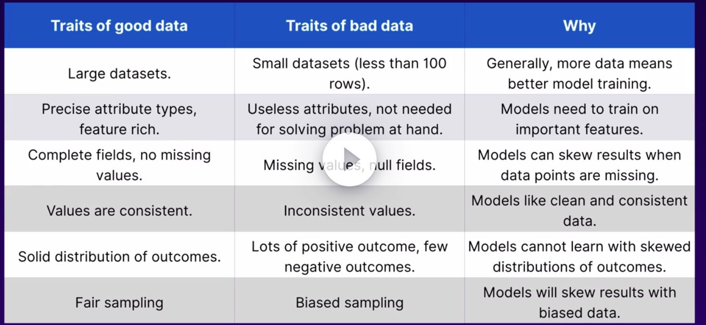
Data Terminology:
- Understaning the terminolgoy allows us to define and descrive our data.
- Semi structured data: XML, JSON
- Structured: Excel, CSV, Relational Databases
- Unstructures: Audio files, log files, tweets
- Relational Databases: Aurorra, Post SQL, MySQL, Oracle , Maria DB, MS SQL Server
- Data Warehouse: Collect data from many sources, and many different formats, and congregate them in data warehouse. After cleaning they land here. So we can using BI tools on data in data warehouse.
- Data Lakes: Dump the collected data in data lakes. ML, Analytics, Data Movement, real time data movement all dumped here log files. No procss for dumping data. Used for storing data which we arent sure what to do. No preprocessing
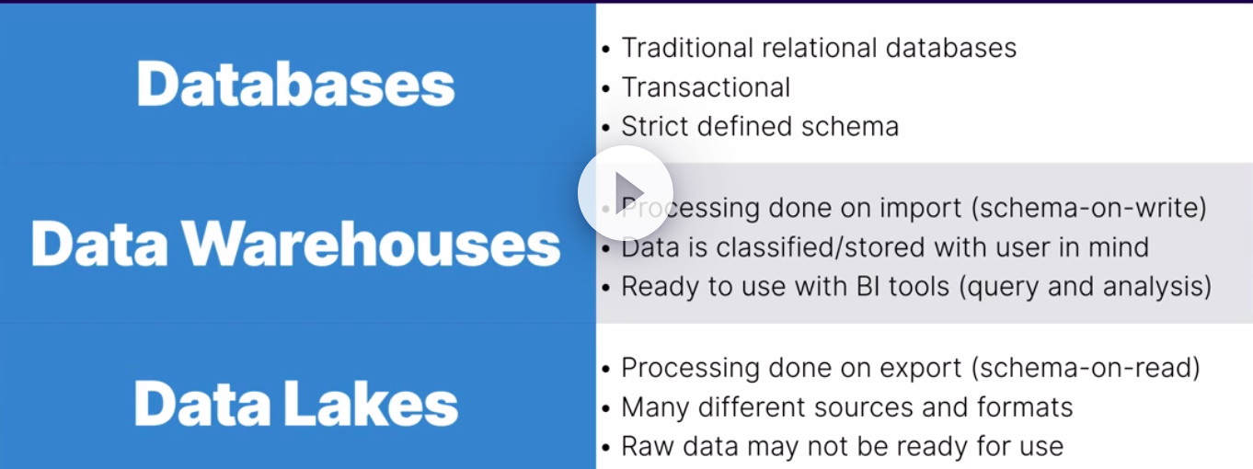
d

Machine Learning Terminology:
- Labeled and Unlabeled data. - data collected with no target attribute
- unlabeled – logs, audio files, tweets, survellance videos, blog posts, web traffic acess, stock market prices. - UNSUPERVISED
- lableeded – spam, housing prices, tumor images of malign, customer churn data, fraudulent trans, lableed audio or video - SUPERVISED
- Categorical and Continuous
- Categorical – Non Measurable, qualitative
- Continutous – Quantitative, measurable,
- Ground Truth – Truth data, its already labeled. Refers to factual data that has been observed or measured. It allows diffferent types of tagging/labeling processes. Easily create labeled data.
- Image data – Tagged images dataset. Used for face recognintion, handwritten, age prediction, gender prediction.
- MNIST Data- numbers
- Image Net – all images -
- TimeSeries data – stock market pricing. IoT devices, web traffic, trails and patterns

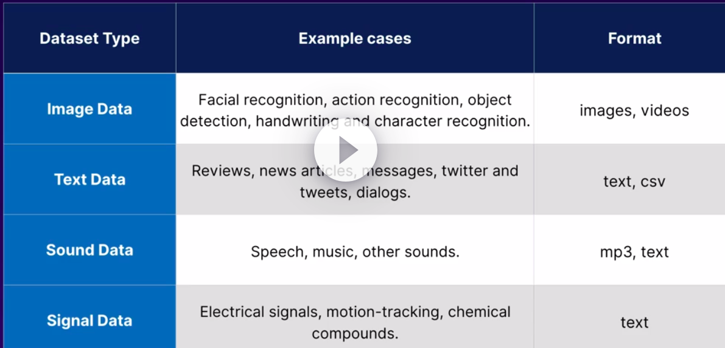
fdfd

fgf

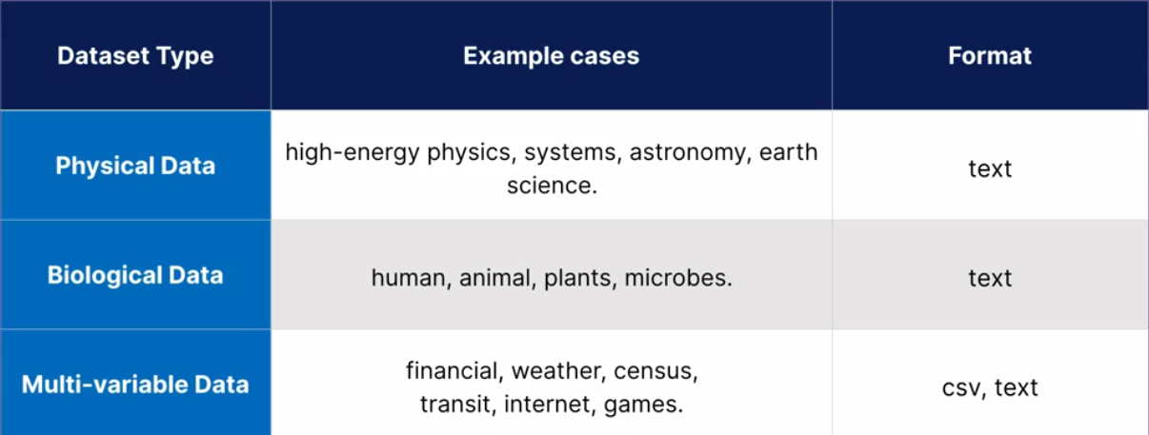
fgf

AWS Datastores:
- S3: integrates directly with ML
- unlimited storage that provides object based storage for any type of data.
- Files can be from 0 to 5TB
- there is unlimited storage.
- Files are stored into buckets
- S3 is a universal namesapace, that is names ust be unique globally.
- S3.regionname. /foldername .. this is unique.
- Bucketname.s3.aamazonaws. Com from sp 2020.
- RDS: Relational Data Base Service
- Has Amazon Aurora, MySQL, MariaDB, Postgre, ORACLE, SQL Server
- DynamoDB:
- Unstructed, or Schemaless – Semi Structured data
- Amazon Redshift:
- Check the leccture
- fully managed clusterd – S3, dynamodb,
- allows to store massive amount createing Data Warehouse.
- Timestream:
- not likely on the exam – time series data generally, server logs, stock market prices,
- DocumentDB:
- most likely not on exam
- mongoDB, better performance with mongoDB,
- Solution Architect or Developer Associate.

AWS Migration Tools
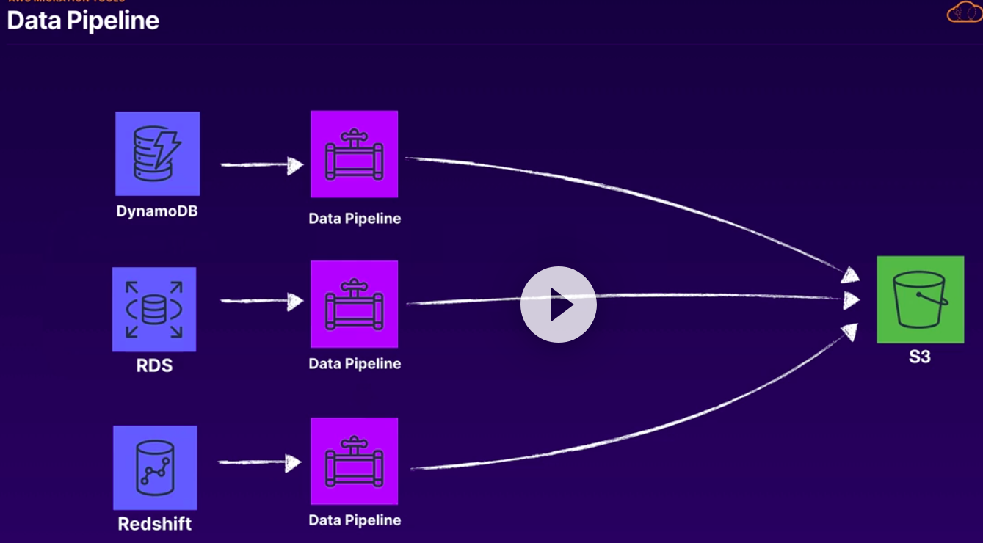
- From one service to other
- Data pipeline, DMS, and AWS Glue
- Data Pipeline:
- from onpremise to AWS
- CopyActivity, Emr Activity, Hadeoop activity, Hive, Hive copy, et
- can also be used as transformation also.

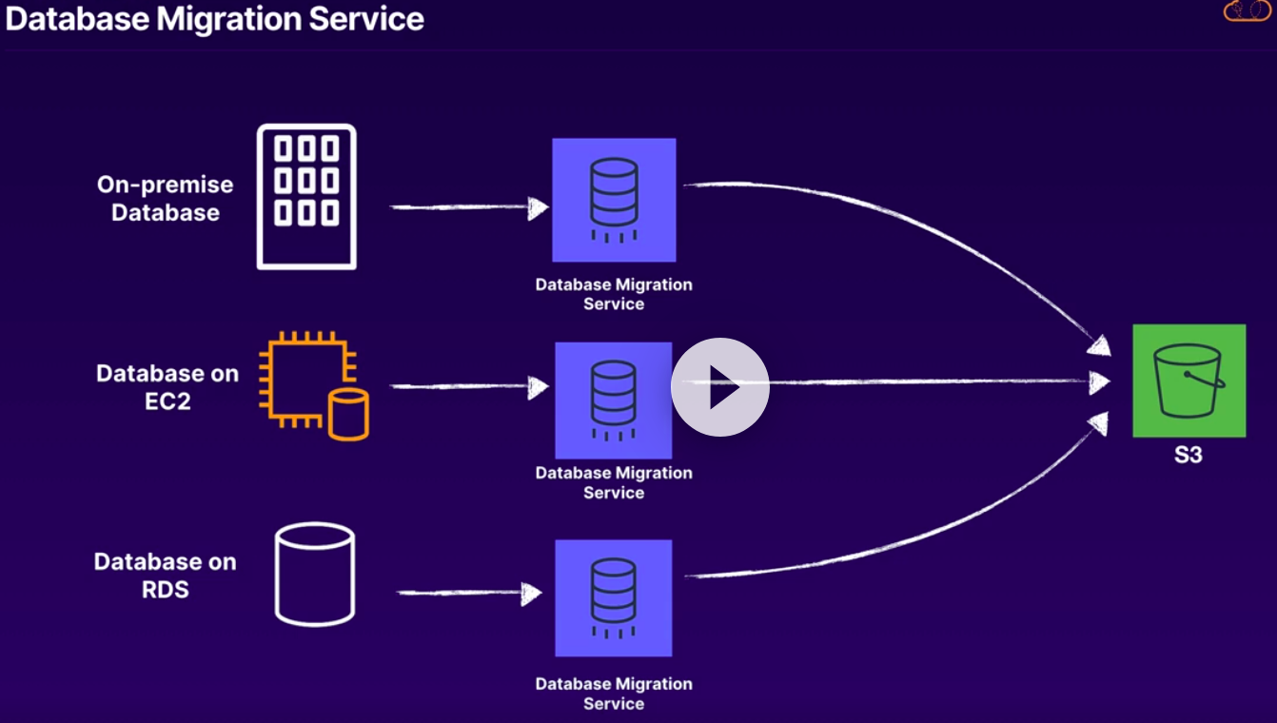
- DMS
- Database Migration Service
- Between two relational databases usually. But also for S3
- Homogeneous : MySQL to MySQL
- Heterogeneous: MySQL to S3,
- doesnt support transformation except few basics. Changing column name etc.
- DMS :DMS handles heavy lifting
- Data Pipeline: set up resources as needed but custom way
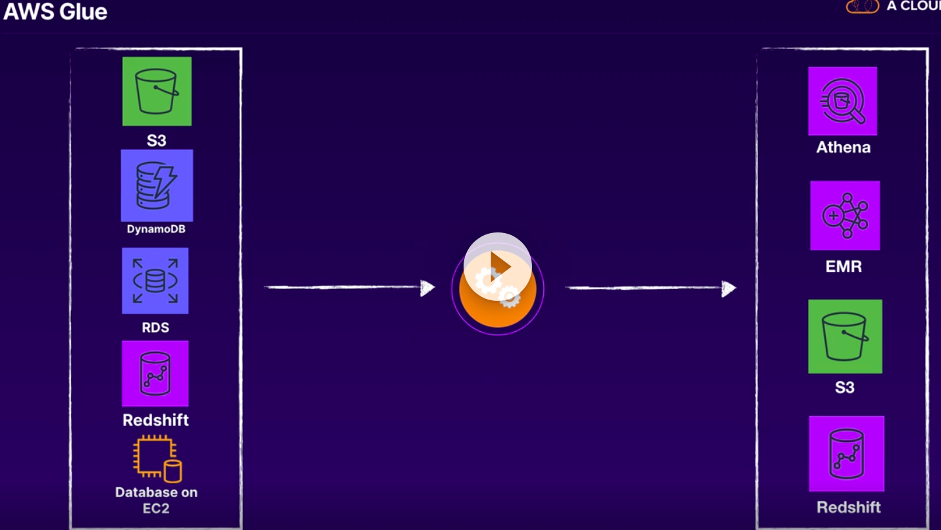

- AWS Glue
- Focus on ETL, mostly on load.

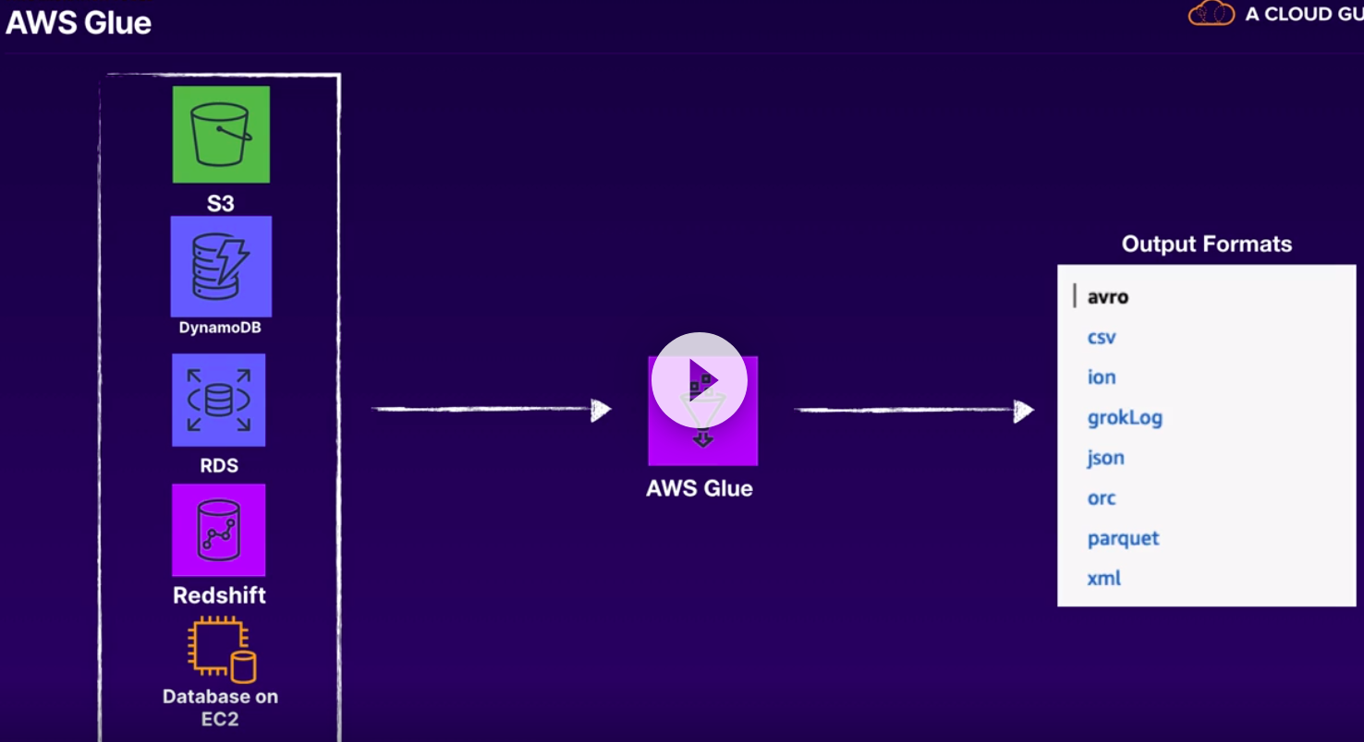
A
vbcvb
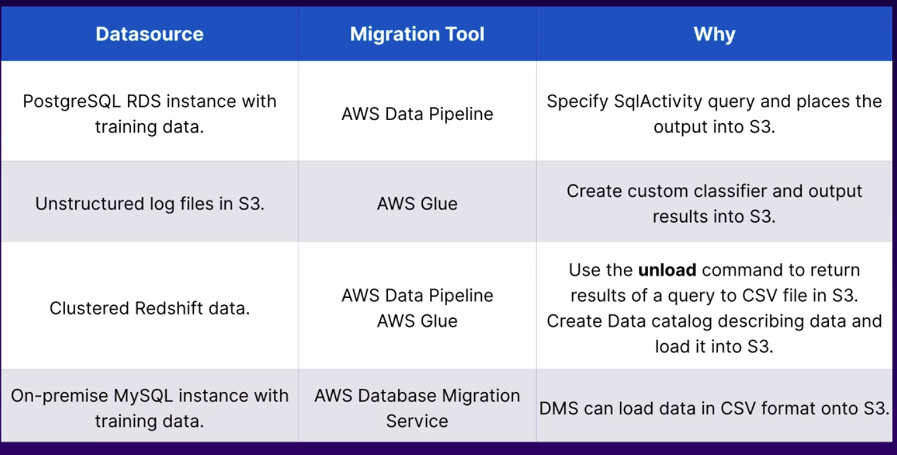
dfdfd
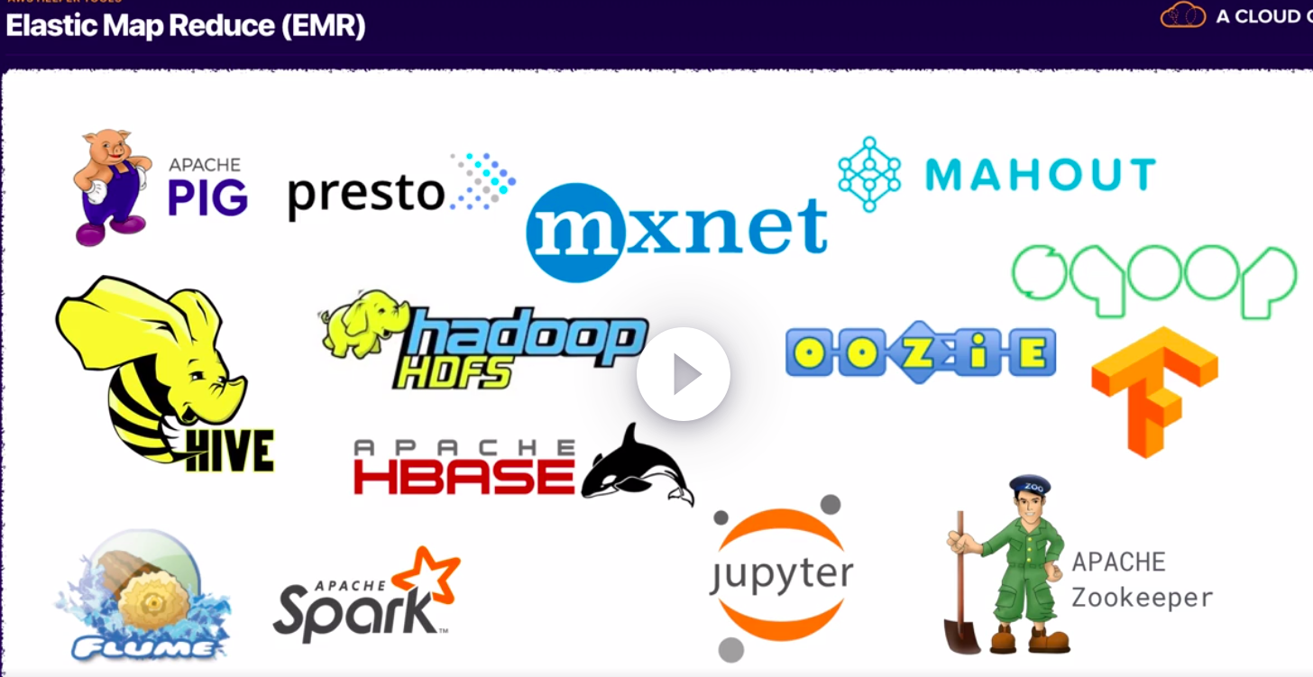

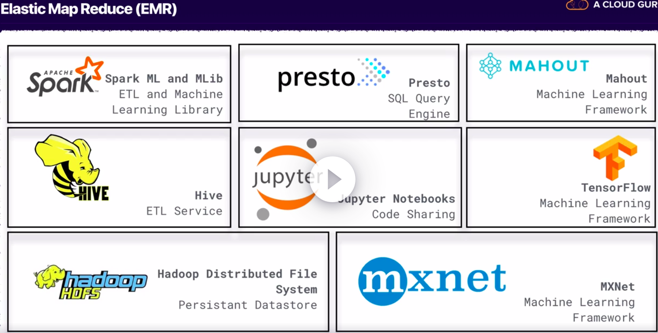
cfvv
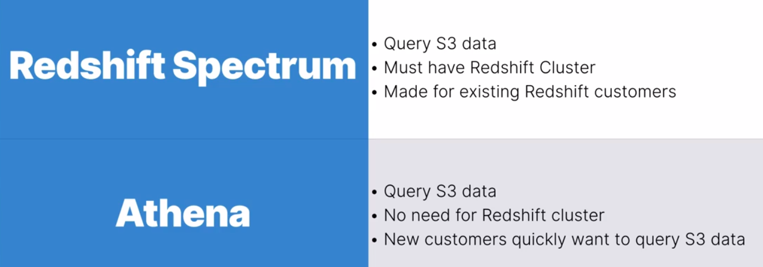

Streaming Data Collection Concepts

Basic Concepts
- 2000 BC – Egypt collected data for taxes,
- Static data and streaming data
- Data in warehouses and lakes is considered Static
- Streaming : Continuous data
- Kaggle provides various datasets. Statis data
- UCI too
- registry open data aws – too
- Google Bigquery
- Financial sources, Stock prices, real estates tracking customers, sensor data, Click streaming data– Streaming data
- Ways to deal streaming data - Some streaming process or process in batches
- Kinesis family consists of various streaming sources .
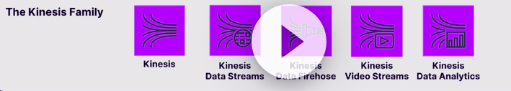

Kinesis Data Streams
- Typically we get data from data producers, which have this data in json payload.
- Data producers – application log files, social media streams, IoT devices, clickstream data, user interaction with web,
- Shard – container that holds data to be sent to AWS

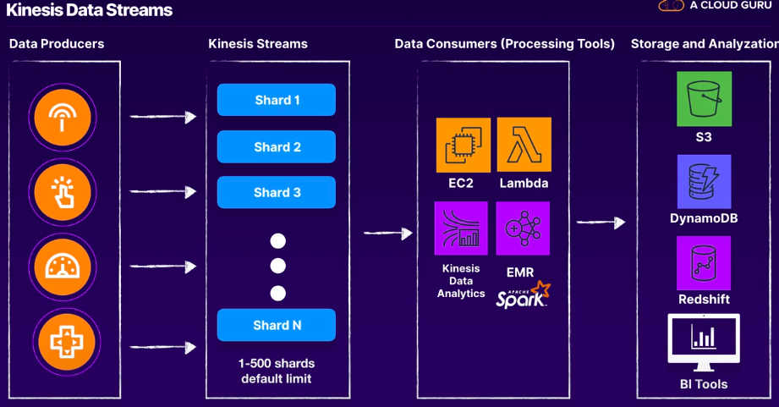
- Shards are rappers or containers. Made up of different parts.. unique partition key for each shard.
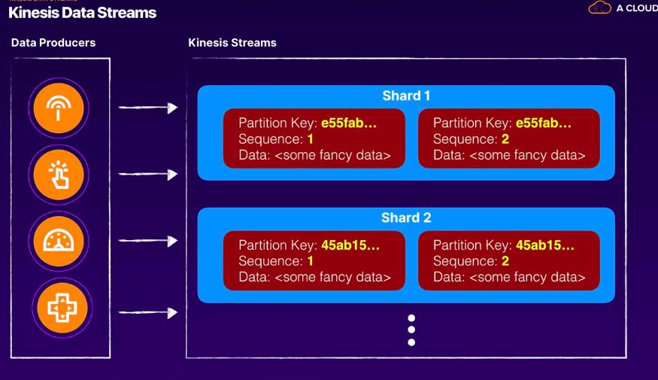
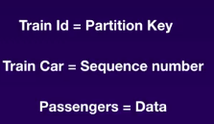

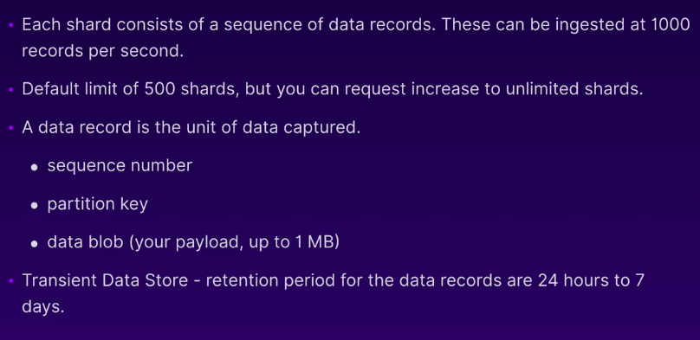
- Maximum upto 500. but can be requested. As the data increases, we need more shards
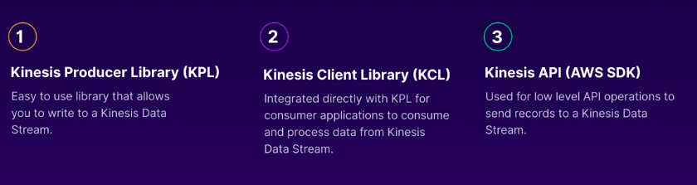
- KPL - Kinesis Producer Library – Install this in EC2 or other jobs for writing data to kinesis streams.
- KCL - Kinesis
- Kinesis API
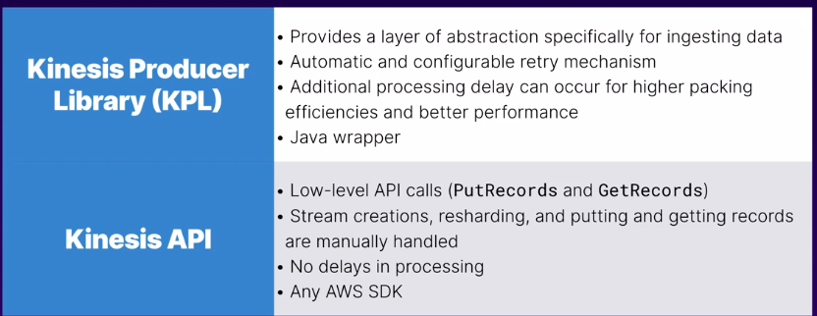
- lkl
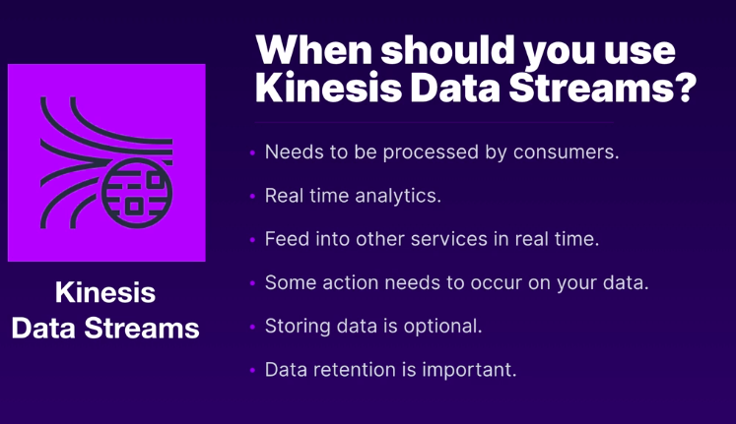
- from 24 hrs to 7 days of retentiion
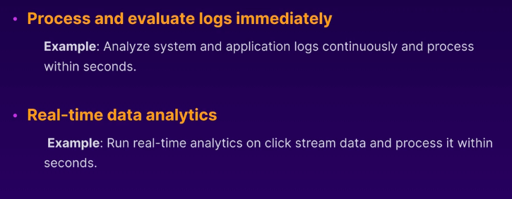

Kinesis Firehose
- No longer worry about shards
- Can deliver the data directly to S3 and other storage options.
- Lambda acts as ETL and preprocessing - This is optional

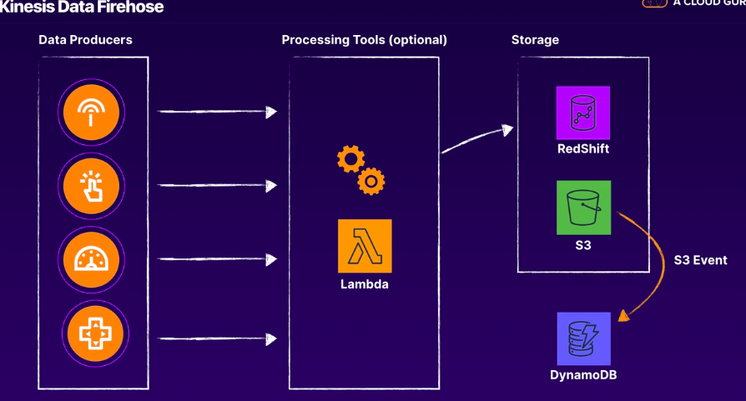

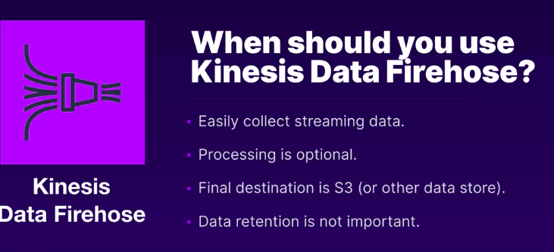
iii
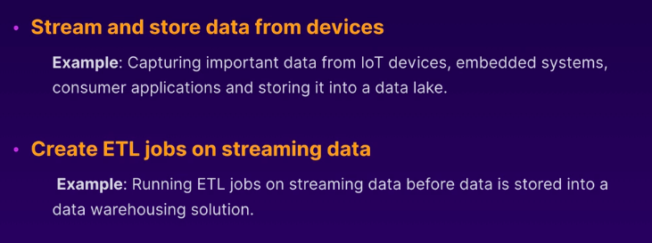

Kinesis Video Analytics
- Audio, video and images, radar,webcam, etc
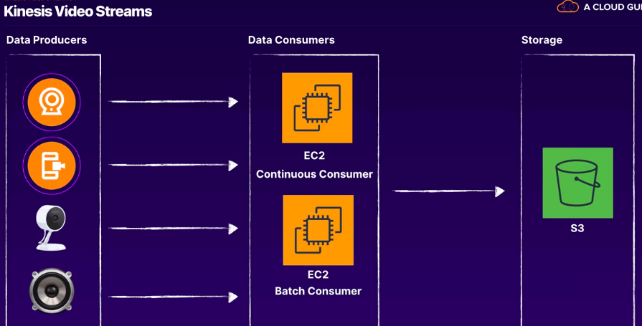
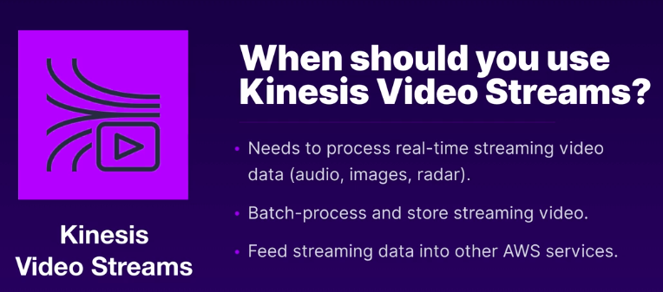
klk

Kinesis Data Analytics
- Run SQL queries, change data types, analytics on real time data
- Kinesis Data StreaKinesis Data Streams and Kinesis Data Analytics cannot write data directly to S3. Kinesis Data Firehose is used as the main delivery mechanism for outputting data into S3.ms and Kin
- the KPL must be installed as a Java application before it can be used with your Kinesis Data Streams. There are ways to process KPL serialized data within AWS Lambda, in Java, Node.js, and Python, but not if these answers mentions Lambda.esis Data Ana

- The question is about sending data to Kinesis synchronously vs. asynchronously. PutRecords is a synchronous send function, so it must be used for the first event type (critical events). The Kinesis Producer Library (KPL) implements an asynchronous send function, so it can be used for the second event type. In this scenario, the reason to use the KPL over the PutRecords API call is because: KPL can incur an additional processing delay of up to RecordMaxBufferedTime within the library (user-configurable). Larger values of RecordMaxBufferedTime results in higher packing efficiencies and better performance. Applications that cannot tolerate this additional delay may need to use the AWS SDK directly. For more information about using the AWS SDK with Kinesis Data Streams, see Developing Producers Using the Amazon Kinesis Data Streams API with the AWS SDK for Java. For more information about RecordMaxBufferedTime and other user-configurable properties of the KPL, see Configuring the Kinesis Producer Library.lytics cannot write data directly to S3. Kinesis Data Firehose is used as the main delivery mechanism for ou

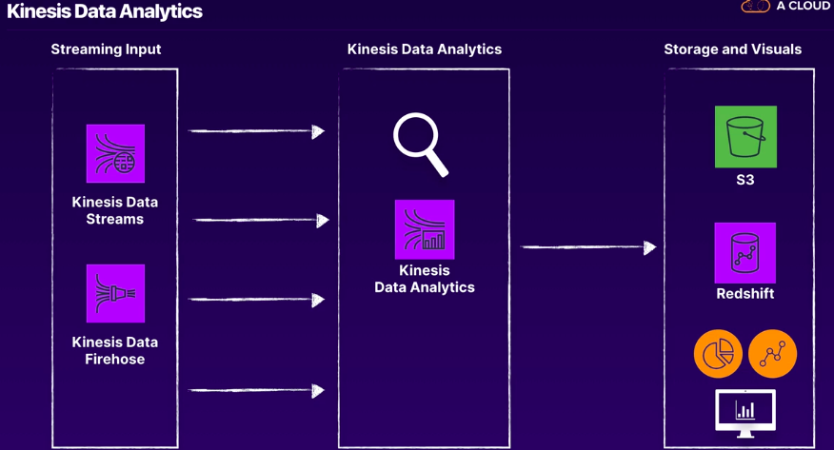
fd
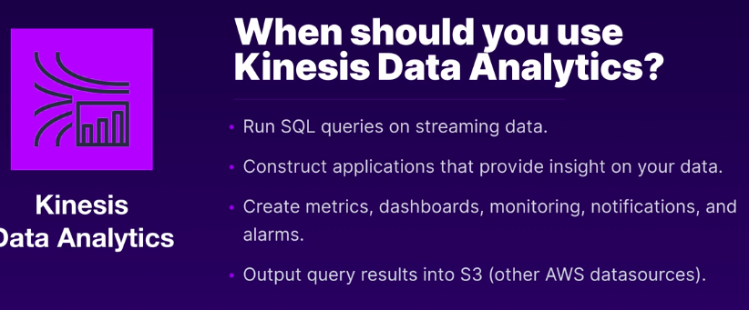
dfd
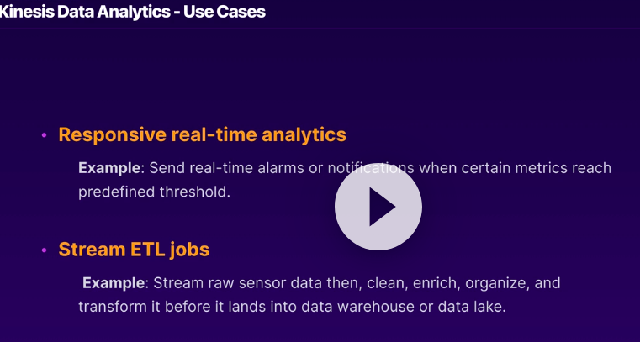

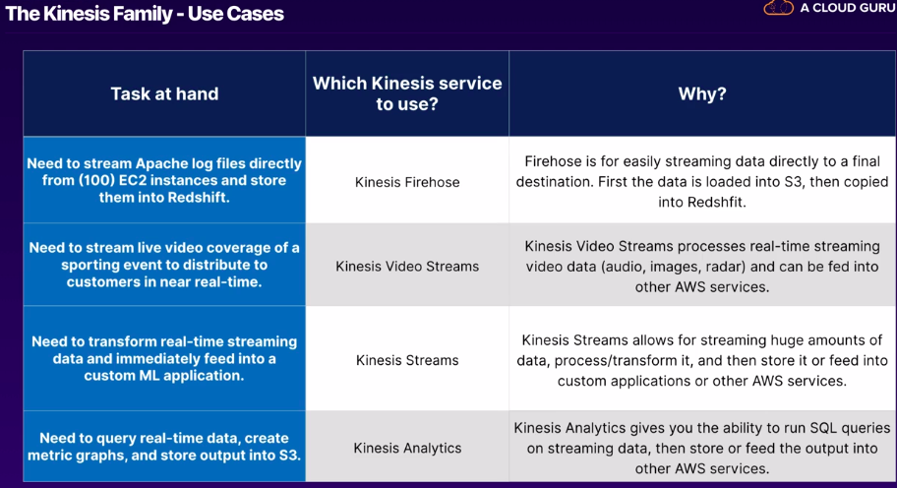
lk

Use this API to gather streaming data from the web.
https://api.randomuser.me/

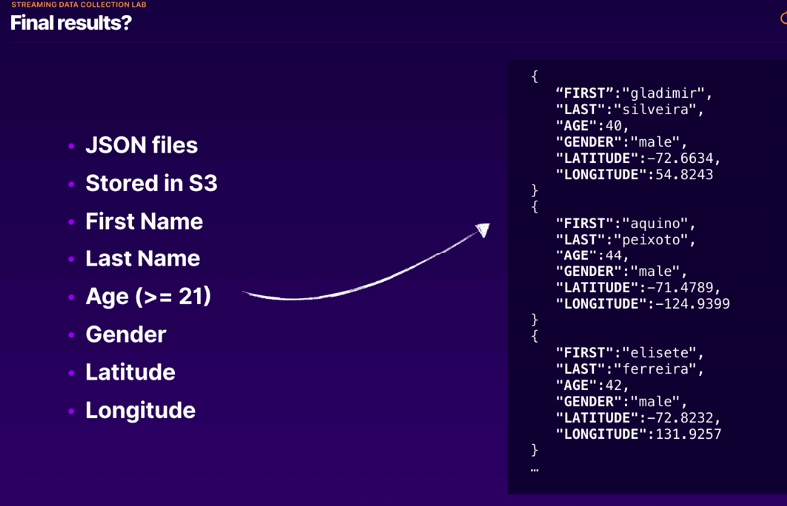
Lsdd

Listen before Exam

Kinesis
https://cloud.google.com/bigquery/
https://www.youtube.com/watch?v=jKPlGznbfZ0
https://docs.aws.amazon.com/streams/latest/dev/key-concepts.html
https://www.youtube.com/watch?v=0AGNcZfYkzw
https://docs.aws.amazon.com/firehose/latest/dev/what-is-this-service.html
https://www.youtube.com/watch?v=EzxRtfSKlUA
https://aws.amazon.com/blogs/machine-learning/analyze-live-video-at-scale-in-real-time-using-amazon-kinesis-video-streams-and-amazon-sagemaker/
https://www.youtube.com/watch?v=dNp1emFFGbU
https://aws.amazon.com/blogs/big-data/create-real-time-clickstream-sessions-and-run-analytics-with-amazon-kinesis-data-analytics-aws-glue-and-amazon-athena/
https://aws.amazon.com/blogs/big-data/joining-and-enriching-streaming-data-on-amazon-kinesis/
https://www.youtube.com/watch?v=EzxRtfSKlUA
https://aws.amazon.com/blogs/machine-learning/analyze-live-video-at-scale-in-real-time-using-amazon-kinesis-video-streams-and-amazon-sagemaker/
https://d0.awsstatic.com/whitepapers/whitepaper-streaming-data-solutions-on-aws-with-amazon-kinesis.pdf
https://www.youtube.com/watch?v=M8jVTI0wHFM

Data Preparation
- Categorical Encoding
- Feature Engineering
- Missing Values

Before Exam:
https://pandas.pydata.org/pandas-docs/stable/reference/api/pandas.get_dummies.html
https://pandas.pydata.org/pandas-docs/stable/reference/api/pandas.Series.map.html

Feature Engineering
https://scikit-learn.org/stable/modules/generated/sklearn.feature_extraction.text.TfidfVectorizer.html
https://kite.com/python/docs/nltk.ngrams
https://www.rdocumentation.org/packages/quanteda/versions/0.7.2-1/topics/ngrams

When can ngrams useful – groups of words and two words residing beside each other.

Numeric Feature Engineering
https://scikit-learn.org/stable/modules/generated/sklearn.preprocessing.MinMaxScaler.html
https://scikit-learn.org/stable/modules/generated/sklearn.preprocessing.StandardScaler.html
https://pandas.pydata.org/pandas-docs/version/0.22/generated/pandas.qcut.html

Other Feature Engineering
http://yann.lecun.com/exdb/mnist/
https://docs.aws.amazon.com/sagemaker/latest/dg/cdf-training.html

Missing Values
https://pandas.pydata.org/pandas-docs/stable/reference/api/pandas.DataFrame.mean.html
https://pandas.pydata.org/pandas-docs/stable/reference/api/pandas.DataFrame.median.html
https://pandas.pydata.org/pandas-docs/stable/reference/api/pandas.DataFrame.mode.html
https://pandas.pydata.org/pandas-docs/stable/reference/api/pandas.DataFrame.dropna.html
https://pandas.pydata.org/pandas-docs/stable/reference/api/pandas.DataFrame.fillna.html

Feature Selection

https://pandas.pydata.org/pandas-docs/stable/reference/api/pandas.DataFrame.drop.html

Helper Tools for Data Preparation
https://www.youtube.com/watch?v=3tHUGmlclI4
https://www.youtube.com/watch?v=dada2WzCNPM
https://www.youtube.com/watch?v=z3HeHlWg88M
https://www.youtube.com/watch?v=qgWMfNSN9f4
https://docs.aws.amazon.com/glue/latest/dg/how-it-works.html
https://acloud.guru/series/release-review/view/111?_ga=2.81581854.849955489.1599448605-1798249811.1598770878
https://aws.amazon.com/blogs/big-data/build-a-data-lake-foundation-with-aws-glue-and-amazon-s3/
https://www.youtube.com/watch?v=PHYWI4Y9mzs
https://www.youtube.com/watch?v=3tHUGmlclI4
https://www.youtube.com/watch?v=S_xeHvP7uMo
https://d1.awsstatic.com/whitepapers/aws-power-ml-at-scale.pdf

Data Analysis and Visualization

Before Exam:

Seeing our data relationships

https://www.gapminder.org/tools/#$chart-type=bubbles
https://matplotlib.org/api/_as_gen/matplotlib.pyplot.plot.html
https://matplotlib.org/api/_as_gen/matplotlib.pyplot.scatter.html
https://matplotlib.org/api/_as_gen/matplotlib.pyplot.bar.html
https://matplotlib.org/api/_as_gen/matplotlib.pyplot.plot.html
https://matplotlib.org/api/_as_gen/matplotlib.pyplot.boxplot.html
https://matplotlib.org/api/_as_gen/matplotlib.pyplot.hist.html
https://aws.amazon.com/blogs/big-data/amazon-quicksight-announces-general-availability-of-ml-insights/
https://www.youtube.com/watch?v=FhI1kVABMF0
https://matplotlib.org/

Model Training

Before Exam

Exam
- https://d1.awsstatic.com/whitepapers/aws-managing-ml-projects.pdf
- https://docs.aws.amazon.com/sagemaker/latest/dg/your-algorithms.html
- https://docs.aws.amazon.com/machine-learning/latest/dg/amazon-machine-learning-key-concepts.html
- https://acloudguru-content-attachment-production.s3-accelerate.amazonaws.com/1598031762881-C06L06%20Exam%20Tips_edited.pdf
- https://sagemaker.readthedocs.io/en/stable/algorithms/kmeans.html
- https://docs.aws.amazon.com/sagemaker/latest/dg/k-means-api-config.html

